**DAY 5 TASK:**

**GET**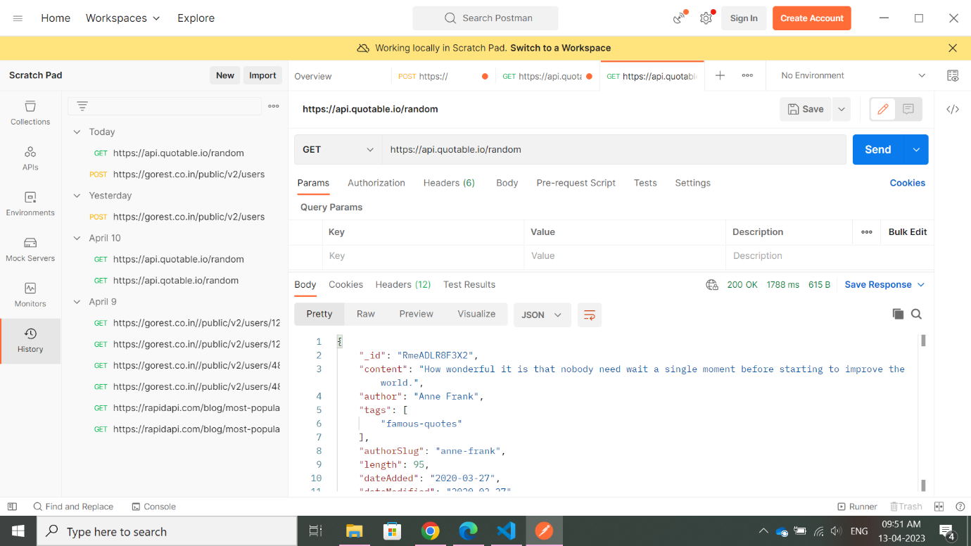

**POST**

**PUT**

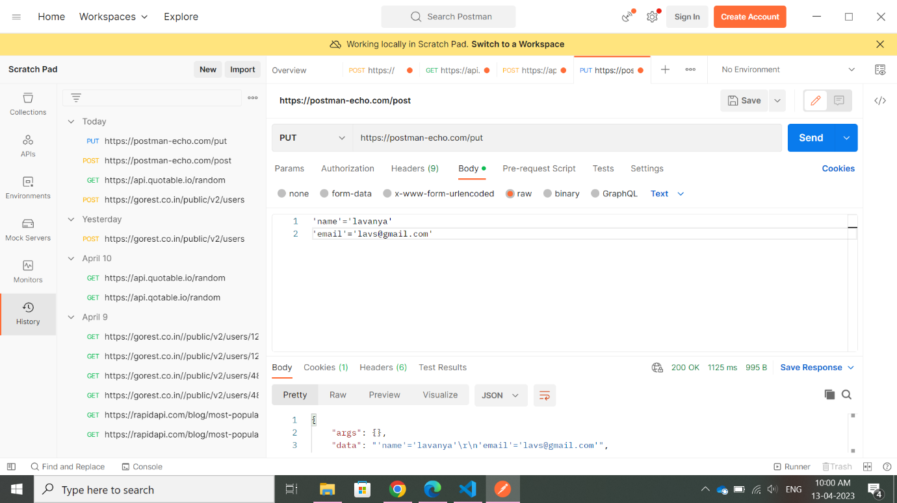

**PATCH**

